Test run document.
First player test run with GUI implemented.
One of the first doors when opened set the values to 1 instead of increasing by one.
In the back end the value for keeping track of how many door had opened was not properly linked.
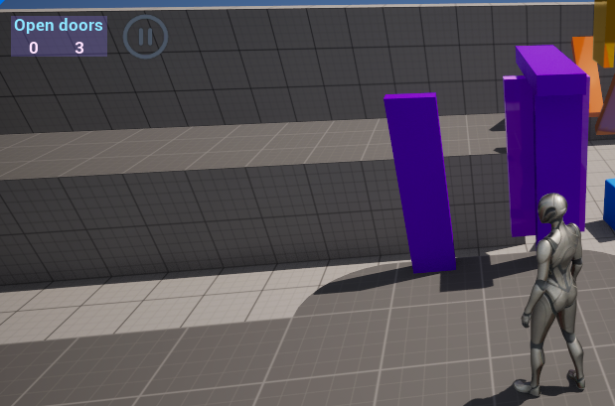
Now the Door is linked
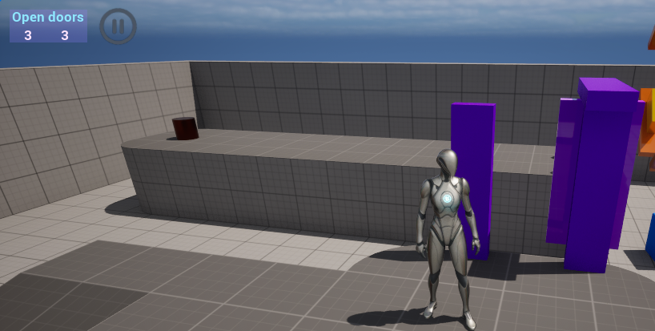

Test run by Another user.
feedback:
1. the on-screen timer is in a fairly prominent place making it sometimes annoying or hard to see what is behind it
2. if you don't open any doors and skip to the end platform using the moveable cubes, it still gives the player a reaction which could cause some confusion
3. the timer doesn't stop after opening all doors and stepping on the tile
1. Before fix
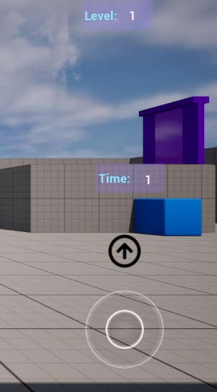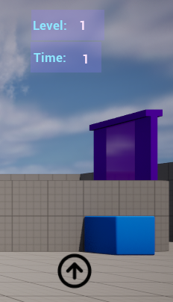 After fix

2. before fix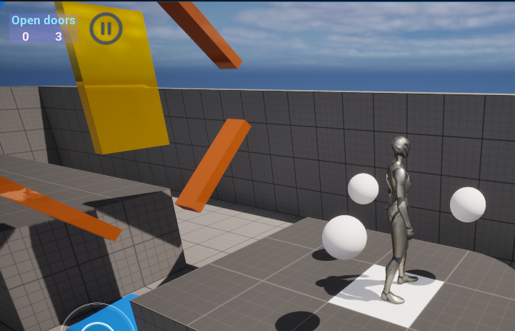
3. After fix
